ENRICHED GEOMETRY SYLLABUS
Be sure to check my website for more info on myself and this class!

mrvenegas.weebly.com
Mr. Venegas
Room 14
Washington Gifted Middle School

Welcome to Geometry Enriched!

This is an enriched 10th grade class in which we will study Euclidian geometry, consider various geometric figures and their properties, proofs, and applications. Students constantly apply their knowledge of algebra, as well as previously learned geometric ideas to new situations in plane geometry, coordinate geometry, three-dimensional geometry, and related applied areas. Geometry topics will be addressed from an advanced viewpoint with an emphasis on utilizing Algebra 1 skills and concepts.

2022 Student Keys to Success

- Maintain the pace of the class: As a result of taking a high school level math class, students will be required to do work every day. I post all instructions, videos, and class messages on Microsoft Teams, so that students can look through the current and previous days’ work. I also use Teams and the book website, savvasrealize.com, to assign work that will be turned in. Students should show their work when possible (non multiple-choice questions), as it shows progress and comprehension of material. In addition, it is the only way I can help students to correct mistakes and master content. Students who are not successful do not maintain the pace of the class and fail to put in the time needed both during class and at home.

- Collaboration: Be prepared to work with others! Collaboration is the best form of learning and discovering. Students would have different partners, seats, and groups almost daily, both during instruction and for collaboration.

- Advocate for your education: Speak up! Ask questions! The fast-paced nature of the class can feel overwhelming at times, so if you are ever stuck on something, if you need more examples, or an alternate explanation….just ASK!

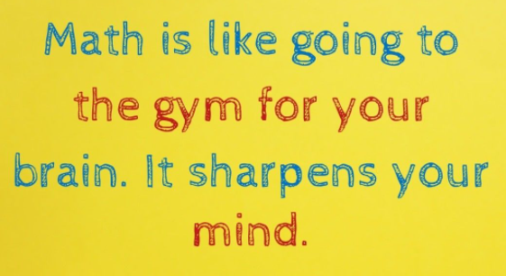

- Need to get in touch with me? Email me at Jeffrey.venegas@psd150.org.

